Topics to consider:
Impact of globalisation on businesses

regional economic integration
Challenges imposed by the replacement of NAFTA->USMCA
Trade wars with China a.k.a. US China + Brexit?
IBM Canada lab

Terms from textbook
Multinational corporations
Borderless corporation
International trade
Free trade
Trade protection / trade deficit / tariffs / import quotas(?)
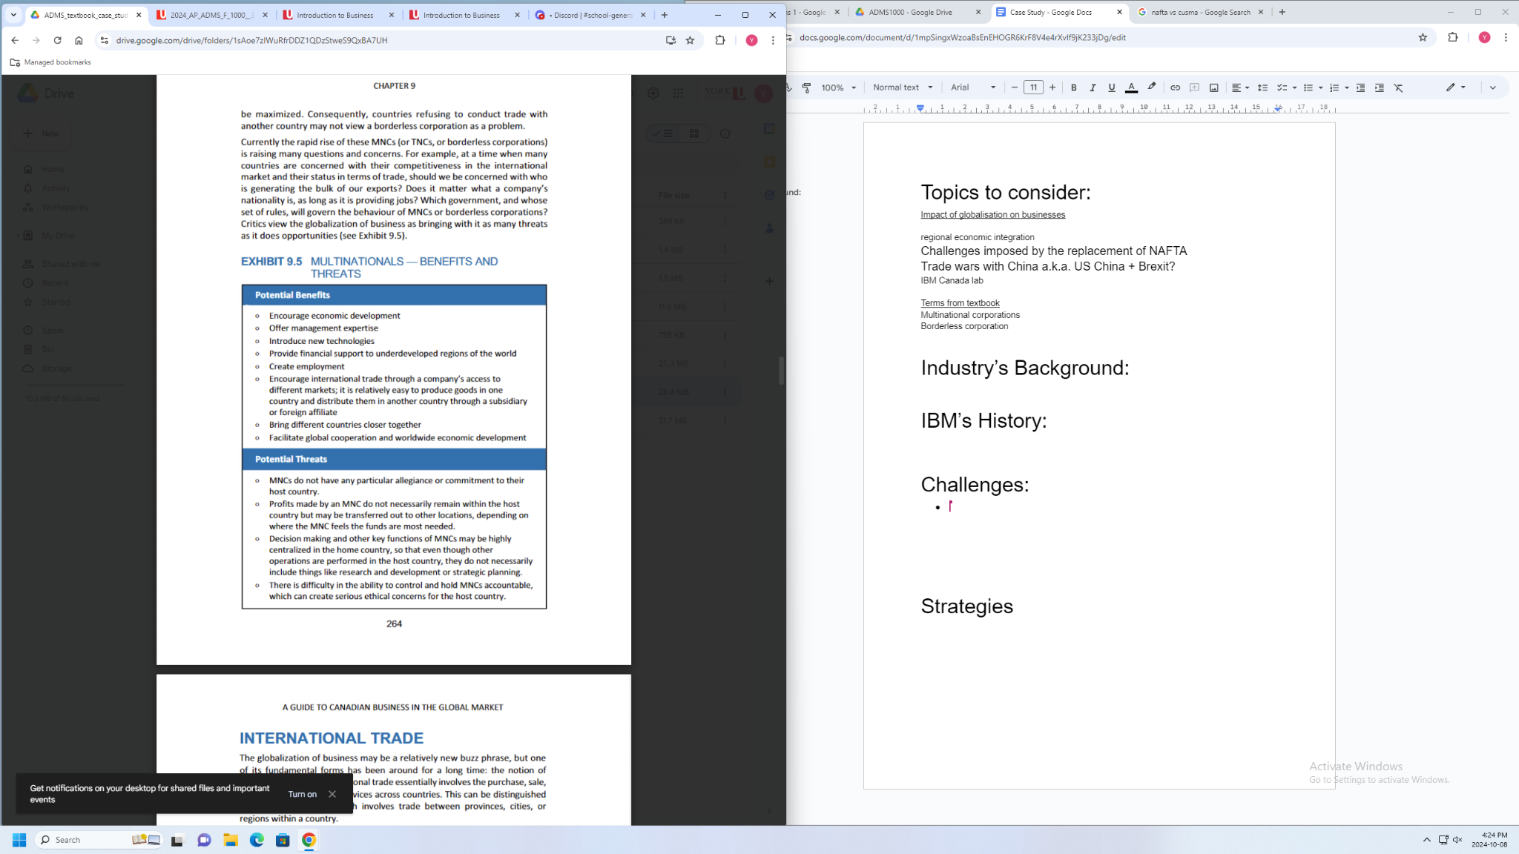

Industry’s Background:

IBM’s History:

Challenges:
- Tech war: Tech war: China narrows AI gap with US despite chip restrictions (msn.com) ; Tech giants caught between escalating U.S.-China tensions (axios.com)
Trump’s avocation (potentially the next president of the US): Trump and Harris clash on US-China tech war: tariffs, chip exports, and America's competitive edge (digitimes.com)
Exports restriction: US further restricts China from AI chips to hinder military development | South China Morning Post (scmp.com)
- IBM China lab: IBM Shuts China R&D Operations in Latest Retreat by U.S. Companies (msn.com); IBM to Shut China R&D Team, Affecting Less Than 1,000 Staff (yahoo.com)
- Tariff and Restrictions:

Strategies
- Supply-chain resilience strategy: https://www.ibm.com/supply-chain
- Localised production: Article on Manufacturing in the US: "How IBM is Reinventing Manufacturing" from Forbes: https://www.forbes.com/sites/bernardmarr/2021/05/03/how-ibm-is-reinventing-manufacturing
- Investment in innovation:
- IBM Research Overview: https://www.research.ibm.com/
- Annual Reports detailing R&D Investments: https://www.ibm.com/investors/financials/annual-reports
- Policy Advocacy:
- IBM’s government relations: https://www.ibm.com/policy/
- IBM’s role in trade policy: https://www.ibm.com/blogs/9-ways-ibm-is-helping-the-u-s-and-world-move-forward/
- Strategic Partnerships:
- Information on IBM partnerships: https://www.ibm.com/partnerworld
- Articles highlighting specific partnerships: https://www.ibm.com/blogs/2022/07/ibm-partnerships/
- Flexible workforce strategy
- IBM’s work-from-anywhere policy:https://www.ibm.com/blogs/jobs/2021/08/ibm-work-from-anywhere/
- Articles on (workforce) flexibility: https://www.ibm.com/blogs/jobs/2021/07/the-future-of-work-at-ibm/
- Focus on sustainability
- IBM Sustainability reports: https://www.ibm.com/ibm/responsibility/
- Articles on IBM’s environmental initiatives: https://www.ibm.com/blogs/2022/03/sustainability-commitments-ibm/

